BIOPAK 240-R BENCH STATEMENTS OF FACT
- Use only exact replacement parts in the configuration as specified by the manufacturer. (User/Benchman: Cautions and Limitations, Special or Critical User’s Instructions)
- The battery is to be changed in fresh air only. (User/Benchman: Cautions and Limitations, Special or Critical User’s Instructions)
- MSHA approved for use with one of the following 9-Volt batteries only: Eveready
Panasonic Rayovac Duracell
(Remote Monitoring System MSHA Electronic Approval Page)
- Never substitute, modify, add, or omit parts. (User/Benchman: Cautions and Limitations, Special or Critical User’s Instructions)
- Prior to using the BioPak 240 Revolution it must be determined that the user is medically fit. (User/Benchman: Cautions and Limitations, Special or Critical User’s Instructions)
- Always handle oxygen cylinders with care to prevent damage. (User/Benchman: Cautions and Limitations, Special or Critical User’s Instructions)
- Do not open the cylinder valve in the presence of open flame, sparks, or high radiant heat. (User/Benchman: Cautions and Limitations, Special or Critical User’s Instructions)
- Oxygen will enhance the combustion of other materials so that materials that normally will not burn in air may burn in oxygen-rich atmospheres; and materials that do burn in air will burn more vigorously and at a higher temperature in oxygen-rich atmospheres. (User/Benchman: Cautions and Limitations, Special or Critical User’s Instructions)
- Oxygen will not cause materials to ignite without the presence of an ignition source. (User/Benchman: Cautions and Limitations, Special or Critical User’s Instructions)
- The use of an SCBA will add to the workload and stress of the user. (User/Benchman: Cautions and Limitations, Special or Critical User’s Instructions)
- The BioPak 240 Revolution is suitable for respiratory protection entry into and escape from oxygen deficient atmospheres with a temperature as low as -5 degrees F (-5F) (-20C). (Users/Benchman: Cautions and Limitations or Critical User’s Instructions)
- The BioPak 240 Revolution is approved when the oxygen cylinder is fully charged with compressed medical or aviation grade oxygen at 3000 psi. (User/Benchman: Cautions and Limitations, Special or Critical User’s Instructions)
- Allow the oxygen cylinder to cool after filling to determine the correct pressure. (User/Benchman: Cautions and Limitations, Special or Critical User’s Instructions)

- A foreign gas may cause cylinder corrosion. (User/Benchman: Cautions and Limitations, Special or Critical User’s Instructions)
- Always check for a current hydrostatic test date. (User/Benchman: Cautions and Limitations, Special or Critical User’s Instructions)
- DOT requires carbon fiber wrapped aluminum cylinders be tested by an approved facility on a 5-year cycle from the date of manufacture. (User/Benchman: Cautions and Limitations, Special or Critical User’s Instructions)
- An unapproved facepiece will compromise the protection provided to the user by the SCBA. (User/Benchman: Cautions and Limitations, Special or Critical User’s Instructions)
- A good facepiece seal is important to achieving full protection and proper SCBA duration. (User/Benchman: Cautions and Limitations, Special or Critical User’s Instructions)
- Users should conform to MSHA/NIOSH guidelines concerning facial hair and
the use of facemasks. (Users/Benchman: Cautions and Limitations or Critical User’s Instructions)
- Replace the battery when the low battery alarm has activated, after 200 hours of use or every 6 months whichever comes first. (Benchman: Section 3.4)
- The connectors of the monitoring device may only be connected to a Biomarine BioPak 240R breathing Apparatus oxygen regulator, manifold block and breathing chamber. (User/Benchman: Cautions and Limitations, Special or Critical User’s Instructions)
- The fiber optic cable may only be connected to the BioPak 240R remote gauge assembly. (User/Benchman: Cautions and Limitations, Special or Critical User’s Instructions)
- Turn-Around maintenance procedures should be performed as soon as possible after each use. (Benchman: Section 1.3)
- It is acceptable to leave the oxygen cylinder in place until after washing and disinfecting has been completed. (Benchman Section 1.2)
- Immediately after completion of BioPak use, remove the used CO2 scrubber canisters. (Benchman: Section 1.2)
- DO NOT submerge the Alarm Module during turn-around maintenance. (Benchman: Section 1.3)
- Do not allow any fluids to contact the input port of the pressure regulator. (Benchman: Section 1.3)
- Use only cleaners and disinfectants that are approved by Biomarine. (Benchman: Section 1.3)

- If Cleaning is not immediately possible after each use, at a minimum remove and discard the CO2 scrubber and moisture pad. (Benchman: Section 1.3)
- Remove the oxygen cylinder making sure the seal washer or outlet tube O-ring remains in place and install the regulator cover. (Benchman: Section 1.2)
- Thoroughly rinse all components in clean water to remove all disinfectant solution. (Benchman: Section 1.3)
- Chronic Obstructive Pulmonary Disease could limit or prevent the use of the BioPak 240 Revolution. (User/Benchman: Cautions and Limitations, Special or Critical User’s Instructions)
- Place freeze forms onto a level surface in a freezer for a minimum of 8-hour period at a temperature of 10 degrees F or less. (Benchman: Section 1.4)
- If the optional magnetic wiper is utilized soak both chamois surfaces of the wiper pieces with water. (User: Section 3.2)
- The manual(s) are the minimum recommended procedures for maintaining the BioPak 240R. (User/Benchman: Cautions and Limitations, Special or Critical User’s Instructions)
- Failure to follow the minimum procedures presented in the manual(s) may violate government or agency approvals as well as void the manufacturer’s warranty. (User/Benchman: Cautions and Limitations, Special or Critical User’s Instructions)
- To prevent mold growth, remove the moisture control foam pads after each use. (Benchman: Section 1.3)
- Do not pre-pack any BioPak that will be stored at temperatures at or below 32 degrees F. (Benchman: Section 1.12)
- Pre-packed carbon dioxide scrubbers may only be stored in the apparatus for a maximum period of 1-year. (Benchman: Section 1.12)
- Record the Carbon Dioxide scrubber serial number and use by date on to the maintenance tag or affix the scrubber label to back of tag. (USER Section 3.5)
- Moisture control sponges must be installed dry when pre-packing the BioPak. (Benchman: Section 1.12)
- Apparatus that are pre-packed with the carbon dioxide scrubber shall be stored within the specific storage temperature and humidity levels and must be sealed air-tight in the apparatus. (Benchman: Section 1.12)
- Failure to install the moisture pad will result in scrubber flooding and cause elevated carbon dioxide levels in the inhalation gas. (Benchman: Section 1.12)
- Users are not permitted to mix versions of the Orbsorb within a BioPak. (Benchman: Section 1.12)

- Install two carbon dioxide scrubber canisters into the breathing chamber making sure that they are properly aligned and fully seated. (Benchman: Section 1.12)
- The alarm system battery shall be replaced after 200-hours of use, every 6-months or after the alarm system low battery alarm flashes with corresponding horn sounding. (Benchman: Section 3.4)
- The oxygen cylinder must be fully charged to above 1500 psi to perform a high-pressure leak test. (Benchman: Section 2.6)
- Use caution when installing the flow restrictor to ensure that the O-ring does not roll out of its gland. (Benchman: Section 3.5)
- The Cylinder should be inspected regularly for signs of damage to the outer wrapping. (Benchman: Section 3.3)
- The Turn-Around Maintenance Tag should be attached to the apparatus in a prominent location to show completion of all maintenance steps. (Benchman: Section 1.1)
- In addition to normal Turn-Around Maintenance, the SCBA shall be visually inspected, and pressure tested on a monthly basis if the apparatus is being used at least once a month or is placed in long term storage. (Benchman: Section 2)
- BioPaks that have been placed in long term storage should have the Long-Term Maintenance Procedure conducted every-6 months. (Benchman: Section 2)
- The LED indication will cease when the pressure gauge reads less than 25 psi. (Benchman: Section 1.10)
- Never pry an O-ring from its glands with a screwdriver. Remove O-rings by hand or with the pick tool provided in the service kit. (Benchman: Section 3.2)
- Cristo-Lube and Dow-111 are the only lubricants approved for use in the apparatus. (Benchman: Section 3.2)
- Never lubricate the outlet tube O-ring or the seal that sits between the oxygen cylinder and the pressure regulator. (Benchman: Section 3.3)
- Cylinders that have been hydro-static tested shall be cleaned for high-pressure oxygen service per national standards. (Benchman: Section 3.3)
- Cylinders are to be retired from service 15-years after the date of manufacture. (Benchman: Section 3.3)
- The Alarm module will require replacement if any damage to the housing is discovered. (Benchman: Section 3.4)
- If the flow does not meet the requirements of the table in the Bench Manual the flow restrictor will need replacement. (Benchman: Section 1.8)
- A good facemask seal is important to achieving full protection and duration. (User/Benchman: Cautions and Limitations, Special or Critical User’s Instructions)

- Personnel who intend to use protective breathing equipment in a dangerous atmosphere must have the proper training, temperament, and experience. (User/Benchman: Cautions and Limitations, Special or Critical User’s Instructions)
- A clean-shaven user will significantly increase the chances of achieving an adequate face seal. (User/Benchman: Cautions and Limitations, Special or Critical User’s Instructions)
- The ongoing effectiveness and reliability of any protective breathing equipment is dependent upon the user’s standard of care in maintaining the equipment. (User/Benchman: Cautions and Limitations, Special or Critical User’s Instructions)
- The BioPak has been tested for intrinsic safety in methane-air mixtures only. (User/Benchman: Cautions and Limitations, Special or Critical User’s Instructions)
- The battery is to be changed in fresh air only. Do not change in hazardous areas. (User/Benchman: Cautions and Limitations, Special or Critical User’s Instructions)
- The BioPak is a Self-Contained Closed Circuit Pressure Demand type certified as Entry and Escape with a 4-hour duration. (Benchman: Section 6)
- The constant Add is 1.8 liters average. (Benchman: Section 6)
- The Demand Add flow is a minimum 80 liters per minute. (Benchman: Section 6)
- The oxygen cylinder has a volume of 440 liters at 3000 psi. (Benchman: Section 6)
- The BioPak breathing chamber has a Tidal Volume greater than 6 liters. (Benchman: Section 6)
- For extreme temperature ranges, the BioPak should be configured with ice coolers. When ambient temperatures are greater than 140 degrees F the recommended duration is no more than 15 minutes and is limited by human endurance. (Benchman: Section 6)
- The emergency Add has a minimum flow rate of 80 liters per minute. (Benchman: Section 6)
- The BioPak operational conditions as it relates to relative humidity is 0 to 100%. (Benchman: Section 6)
- BioPak weight fully charged is 34 pounds. (Benchman: Section 6)
- Do not re-use CO2 scrubber chemical. (User/Benchman: Cautions and Limitations, Special or Critical User’s Instructions)
- The flow test results at 0-5280 feet at a cylinder pressure of 1500-2000 shall be 1.8-2.4 liters per minute. (Benchman: Section 1.8)
- During an alarm test the LED indication should turn to a flashing red with a horn sounding when the pressure gauge reads between 650-1000 psi. (Benchman: Section 1.10)

- Do not allow oil, grease, or other foreign materials to come in contact with cylinder, cylinder valve or cylinder pressure regulator to prevent possible ignition. (User/Benchman: Cautions and Limitations, Special or Critical User’s Instructions)
- The end of service life or low Oxygen alarm is a flashing red light and horn sounding. (User: Section 2.7)
- The flashing blue light indicates an Ice Reminder. (User: Section 2.7)
- The pressure gauge is protected against sudden loss of oxygen in the event of a gauge line severing by a manual disconnect located at the gauge pass through point of the housing. (User: Section 2.7)
- A Pacemaker or other Cardiac Condition could limit or prevent the use of the BioPak 240 Revolution. (User/Benchman: Cautions and Limitations, Special or Critical User’s Instructions)
- Breathing difficulties could limit or prevent the use of the BioPak 240 Revolution. (User/Benchman: Cautions and Limitations, Special or Critical User’s Instructions)
- Claustrophobia or anxiety when wearing a SCBA could limit or prevent the use of the BioPak 240 Revolution. (User/Benchman: Cautions and Limitations, Special or Critical User’s Instructions)
- The instructions provided by the USER and BENCHMAN manuals cannot replace accredited training provided by qualified instructors in the proper and safe use of Biomarine breathing apparatus. (User: Section 1.3)
- X-Ray evidence of Pneumonia could limit or prevent the use of the BioPak 240 Revolution. (User/Benchman: Cautions and Limitations, Special or Critical User’s Instruction)
- Epilepsy-Grand Mal or Petit Mal could limit or prevent the use of the BioPak 240 Revolution. (User/Benchman: Cautions and Limitations, Special or Critical User’s Instructions)
- Use the ¼ inch hex driver from the service Kit to remove the flow restrictor. (Benchman Section 3.5)
NOTE: The References listed above for the Statements of Facts can be downloaded for free from Biomarine’s web site.

BioPak 240 Revolution Complete
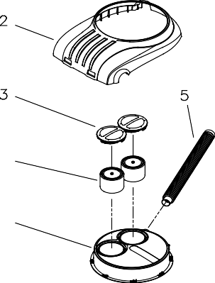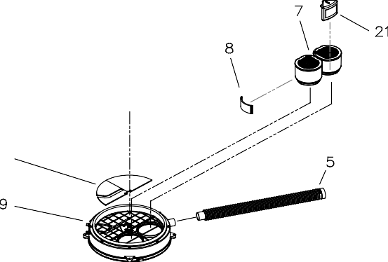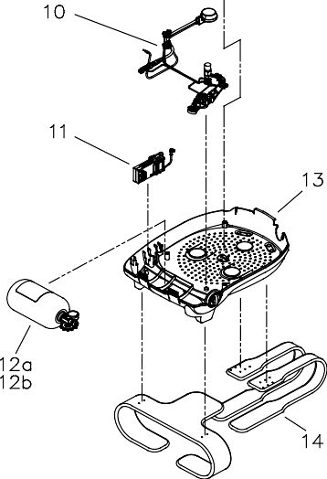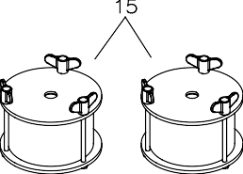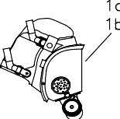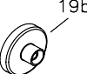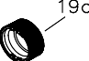

1  Cons. | No. | 2  Designation | 1  Con | 2  s. No. Designation
2 | Upper Housing Assembly |  | 14 | Harness Assembly
3 | Coolant Lid |  | 15 | Ice Canister Freeze Form
4 | Ice Canister |  | 19 | Facemask Storage Plug
5 | Breathing Hose |  | 21 | PCM Heat Exchanger
12 | O2 Cylinder |  | 22 | Moisture Absorbent Pad Set
13 | Lower Housing Assembly

Lower Housing Assembly
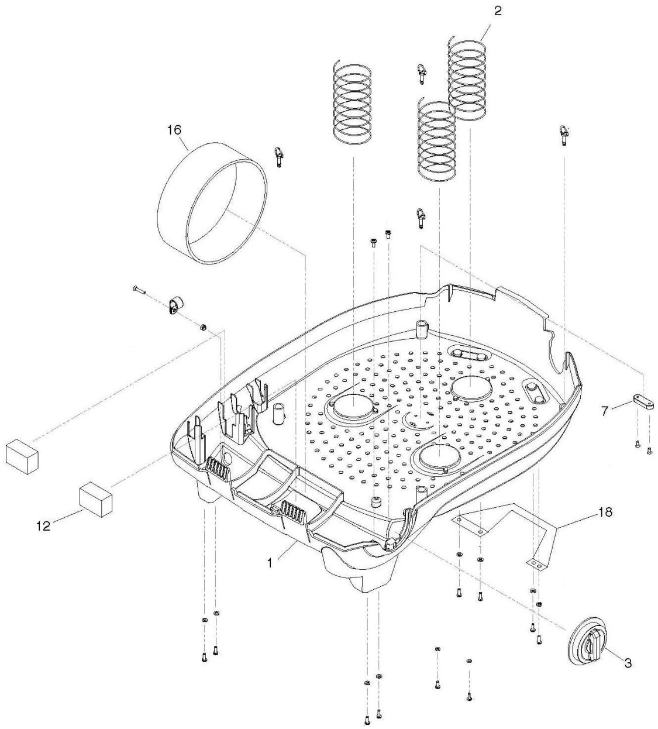

1 2  Cons. No. Designation | 1 2  Cons. No. Designation
- Lower Housing Shell  - Diaphragm Springs  - External Oxygen Knob  7 Vent Spacer | 12 Latch Foam Pad  16 Oxygen Cylinder Hold-Down Strap  18 Carrying Handle

Pneumatic Assembly

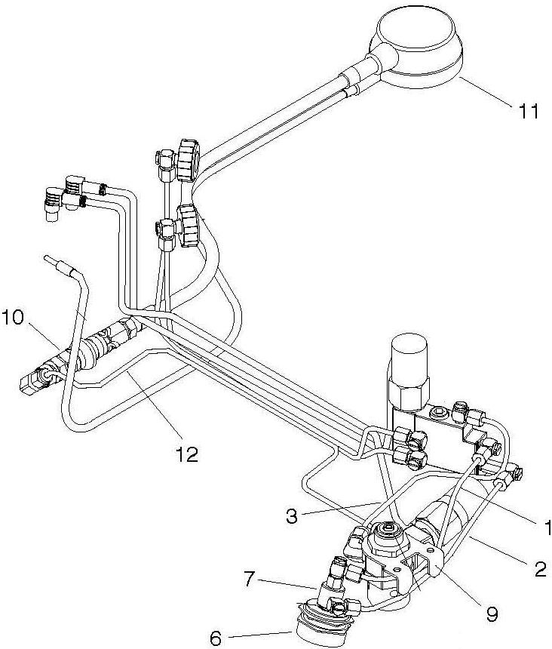

1 2  Cons. No. Designation | 1 2  Cons. No. Designation
- Bypass Feed Tube  - Bypass Return Tube  - Oxygen Feed Tube  - Bypass Valve Push Button  - Bypass Valve | - Oxygen Regulator Assembly  - Remote Gauge Shut Off Assembly  - Remote Gauge Assembly  - Remote Gauge Feed Tube Assembly

Manifold Assembly

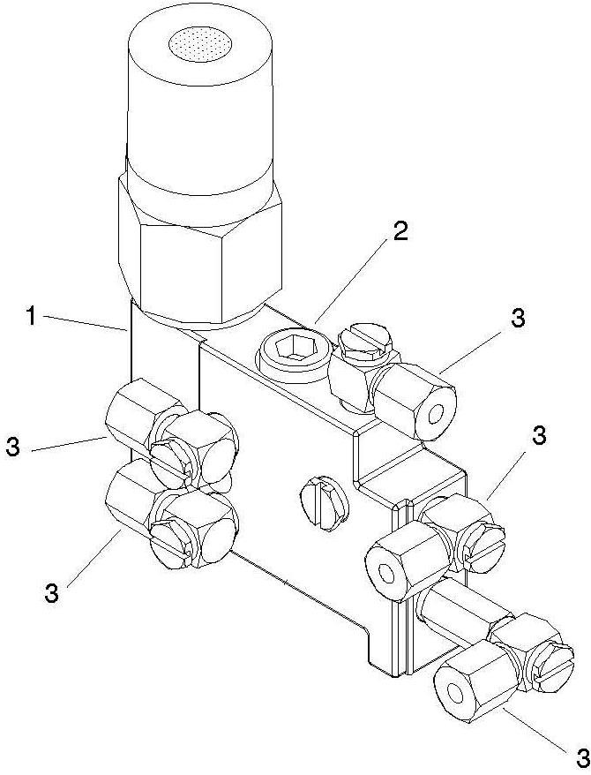

1 2  Cons. No. Designation | 1 2  Cons. No. Designation
- Manifold Block w/Pressure Switch  - Constant Add Flow Restrictor Assembly | 3 Swivel Elbow Fitting

Center Section Assembly

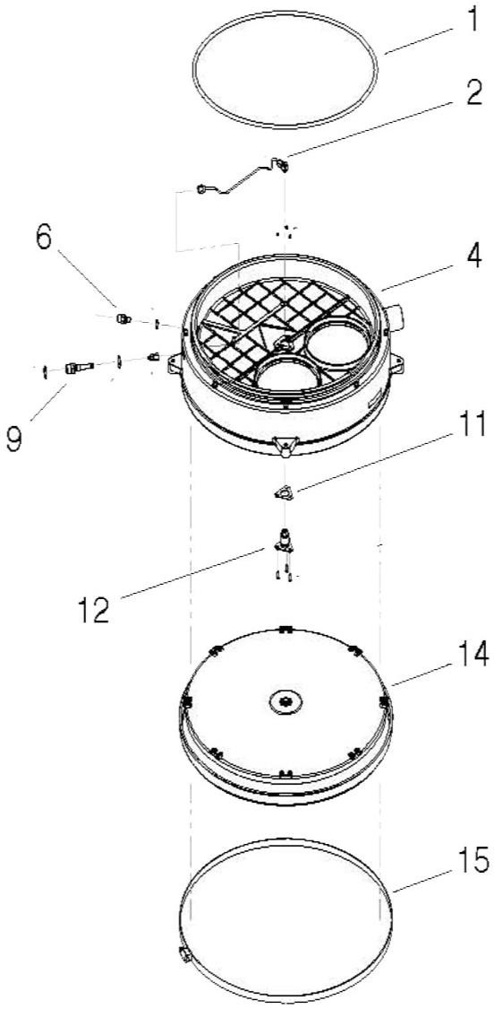

1 2  Cons. No. Designation | 1 2  Cons. No. Designation
- Lid O-Ring  - Demand Feed Tube  4 Center Section Body Assembly  6 Constant Add Fitting  9 Demand Add Fitting | - Demand Valve Gasket  - Demand Valve Assembly  - Flexible Diaphragm  - Diaphragm Clamp

Center Section Lid Assembly

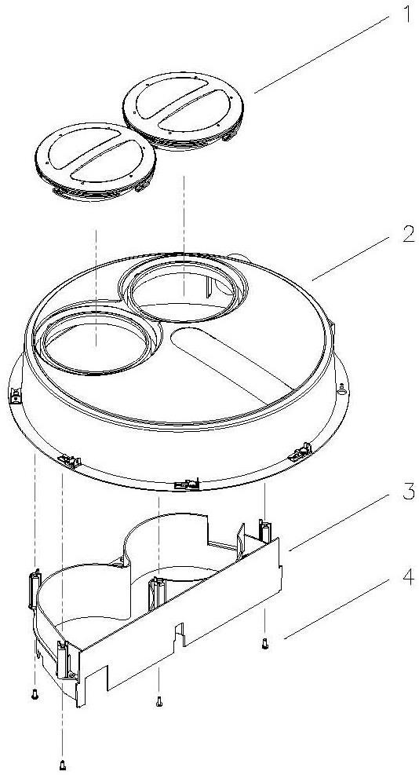

1  Cons. No. | 2  Designation | 1  Cons. No. | 2  Designation
1 | Coolant Lid | 3 | Flow Baffle
2 | Center Section Lid | 4 | Self-Tapping Screws

Diaphragm Assembly

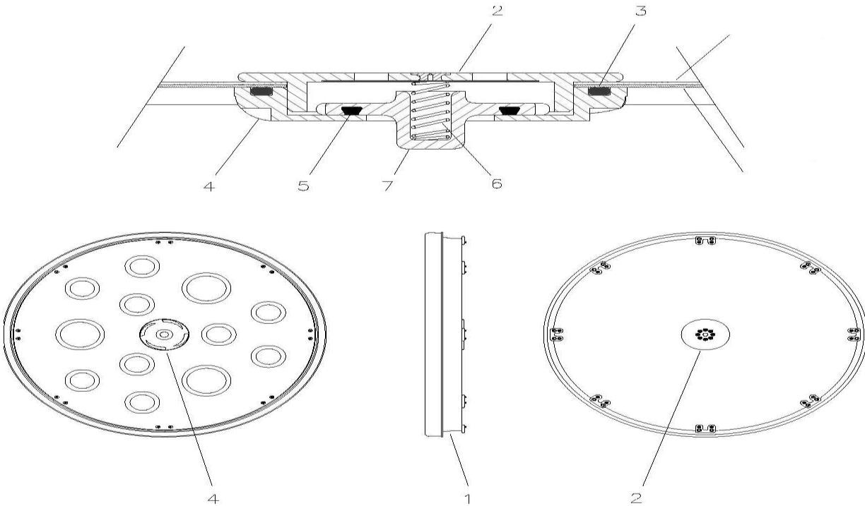

1  Cons. No. | 2  Designation | 1  Cons. No. | 2  Designation
1 | Flexible Diaphragm | 5 | Vent Seat O-Ring
2 | Vent Cap | 6 | Vent Valve Spring
3  4 | Vent Body O-Ring Vent Body | 7 | Vent Valve Seat

Breathing Hose

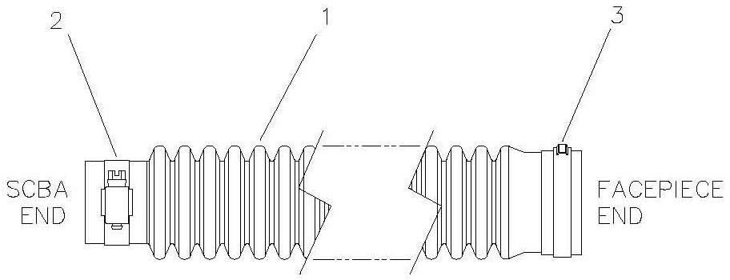

1  Cons. No. | 2  Designation | 1  Cons. No. | 2  Designation
1 | Breathing Hose | 3 | Stepless Ear Clamp
2 | Worm Gear Hose Clamp

Ice Canister Freeze Form

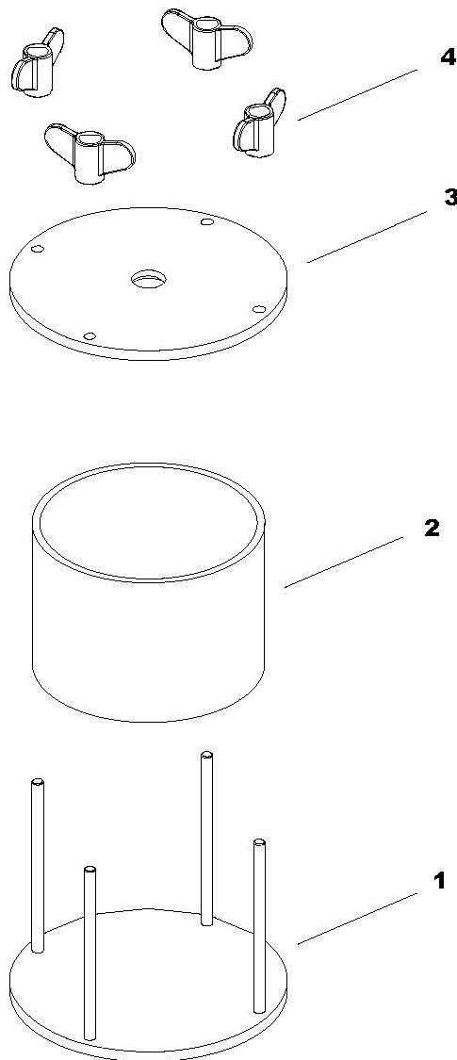

1  Cons. No. | 2  Designation | 1  Cons. No. | 2  Designation
1 | Base Assembly | 3 | Top Plate
2 | Freeze Tube | 4 | Wing Nut

Oxygen Cylinder Assembly

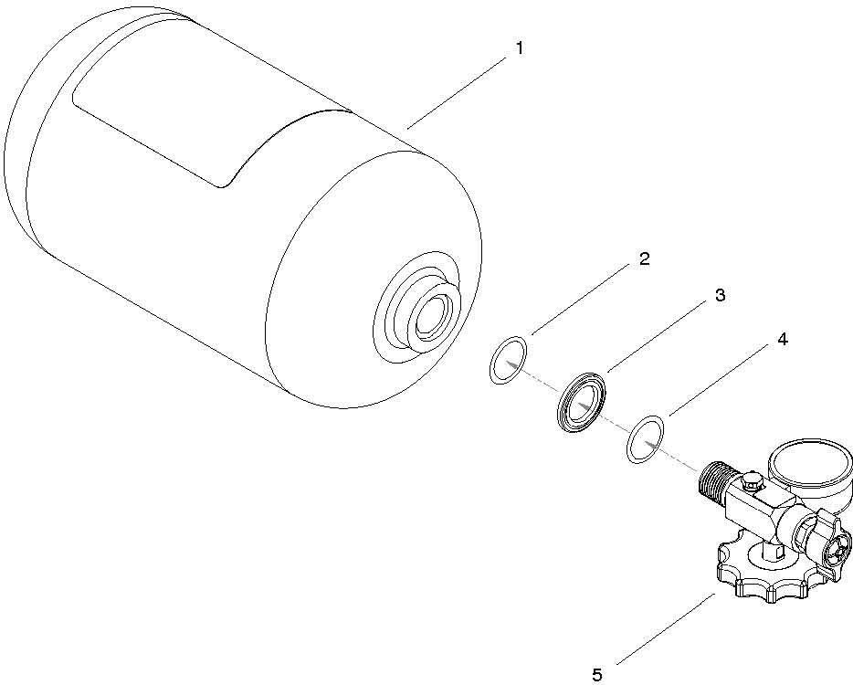

1  Cons. | No. | 2  Designation | 1  Cons. No. | 2  Designation
1 | Green Cylinder |  | 4 | Interior O-Ring
2 | Exterior O-Ring |  | 5 | Valve Assembly
3 | Valve Collar

RMS Monitoring System

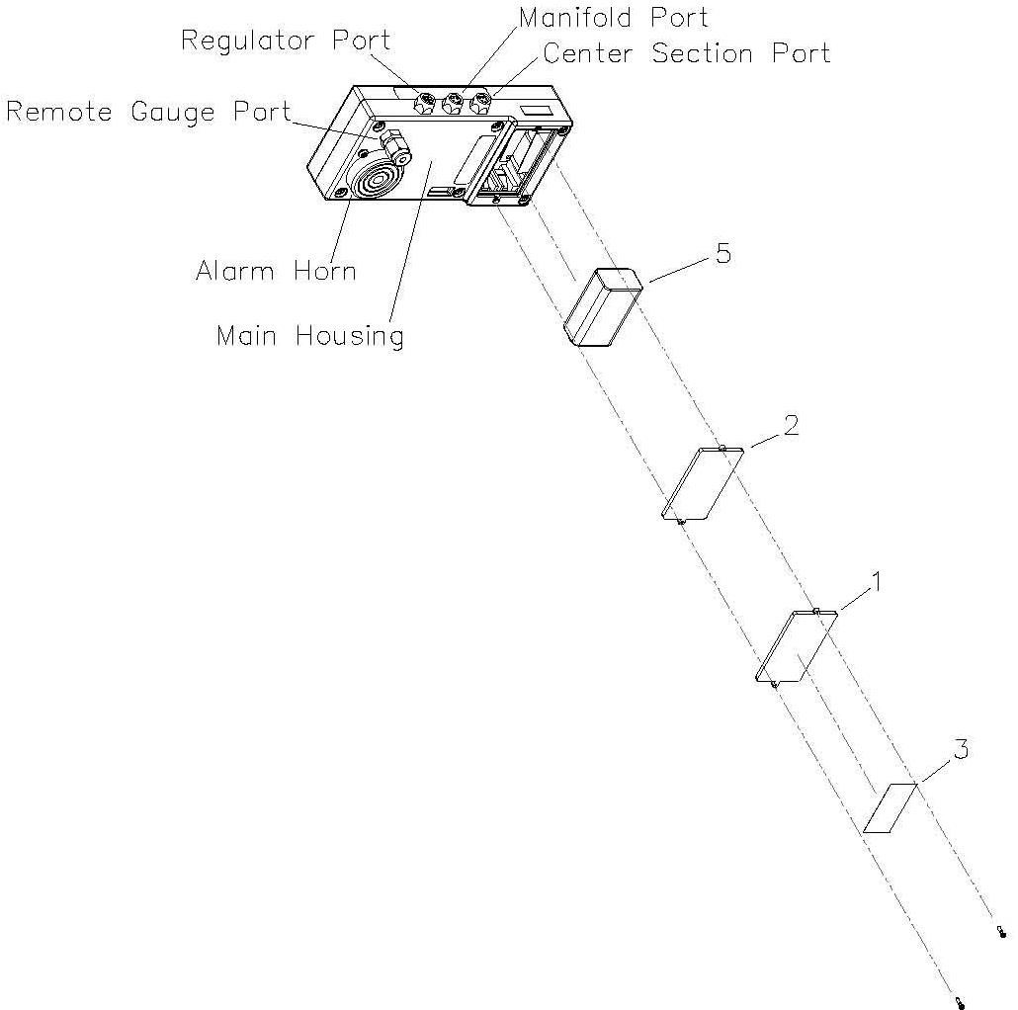

1  Cons. No. | 2  Designation | 1  Con | 2  s. No. Designation
1 | Battery Door | 3 | Battery Door Warning Label
2 | Battery Door Gasket | 5 | 9Vdc Battery

Biomarine Pro PP Mask (Revised Drawing)
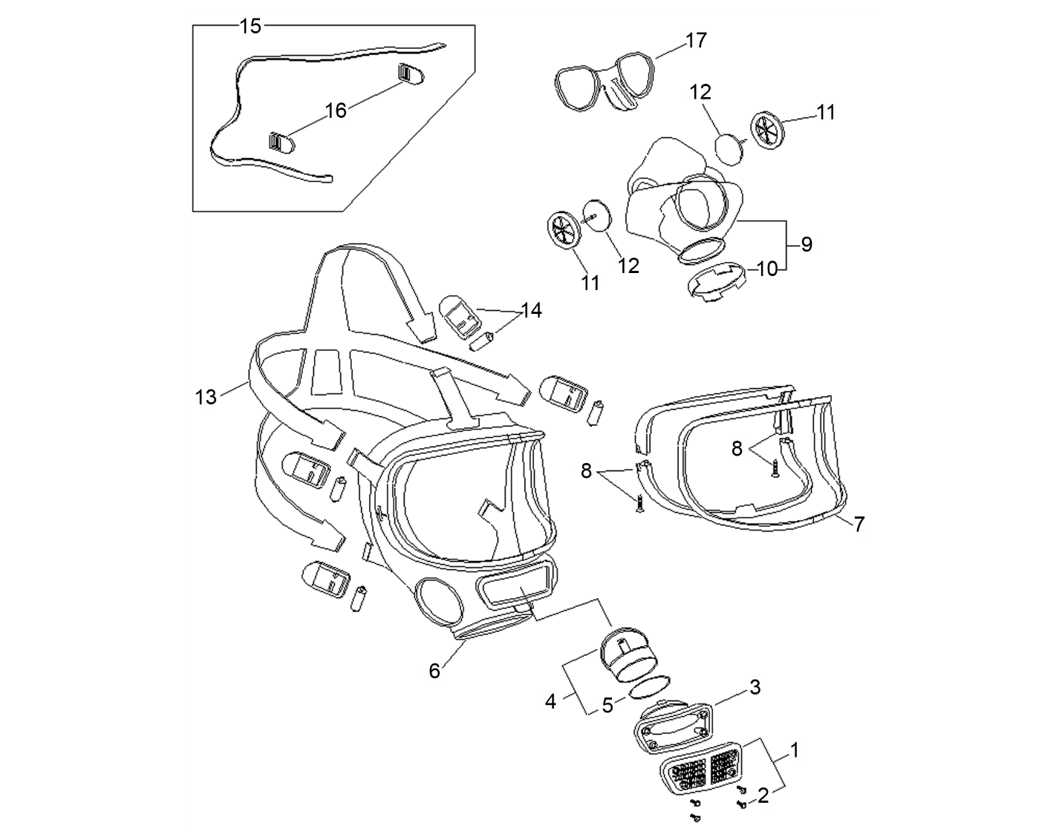

1 2  Cons. No. Designation | 1 2  Cons. No. Designation
- Front Cover & Screws  - Front Cover Screw  - Speech Channel Body  - Speech Diaphragm  - Speech Diaphragm O-Ring  - Outer Mask Assembly  - Visor  - Visor Frame & Screws  - Inner Mask & Ring | - Inner Mask Retaining Ring  - Valve Frame  - Valve Flap  - Web Head-Harness  - Buckle & Roller  - Neck Strap Assembly  - Neck Strap Mounting Clip  - Spectacle Frame

Tool Kit
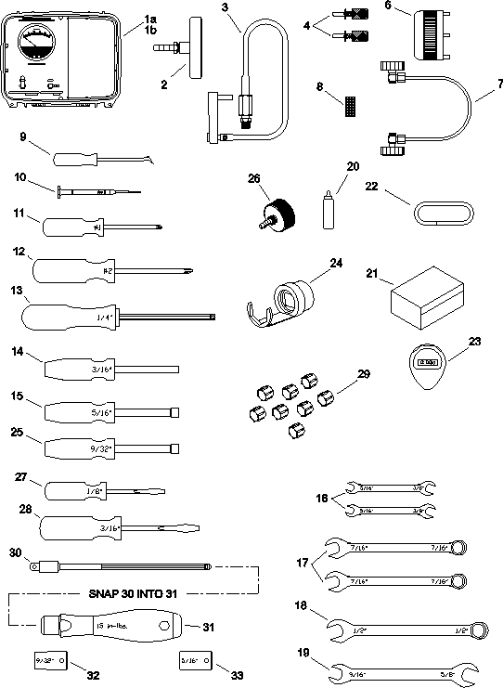

1 2  Cons. No. Designation | 1 2  Cons. No. Designation
1 Case Assembly  26 Leak Check Adapter Fitting  - Flow Test Fixture  - Test Key  6 Vent Valve Wrench | 7 Center Section Pneumatic Plug  9 Combination Pick Tool  13 1/4 - Inch Hex Driver  20 Leak Detection Fluid  22 3/8 – Inch OD Rubber Tubing

